***Enhancing Vehicle-to-Vehicle Communication through Li-Fi Technology for Improved Road Safety***

**Abstract:**

In order to improve road safety and reduce the danger of accidents, this study proposes a revolutionary method of Vehicle-to-Vehicle (V2V) communication utilizing Light Fidelity (Li-Fi) technology. Conventional V2V systems frequently face problems including network congestion, bandwidth limitations, excessive latency, and security flaws since they depend on network-based communication techniques like Wi-Fi or cellular networks. These restrictions may make it more difficult for cars to communicate effectively and safely by compromising the real-time flow of vital information, especially in situations involving heavy traffic or emergencies. The suggested method makes use of Li-Fi, a wireless communication technology that transmits data using visible light, providing a fast, safe, and interference-free substitute. By removing the requirement for intermediary infrastructure, the technology overcomes the drawbacks of conventional systems and allows direct, real-time communication between vehicles via Li-Fi. Important information like speed, distance, and steering direction may be sent quickly thanks to this system, which helps enhance traffic flow and reduce accidents. Li-Fi has a number of benefits over current network-based systems, such as increased security because light waves have a limited range, quicker data transfer speeds, and more dependability. Furthermore, Li-Fi's usage of energy-efficient LEDs lessens the environmental impact of communication systems while simultaneously promoting sustainability. This study highlights how Li-Fi is transforming V2V communication and offering a more effective, safe, and secure solution for changing road conditions.

**Keywords:** Vehicle-to-Vehicle Communication, Li-Fi, Wireless Communication, Road Safety, Security, Data Transmission, Advanced Driver Assistance Systems, Energy Efficiency, Traffic Management, Real-time Communication.

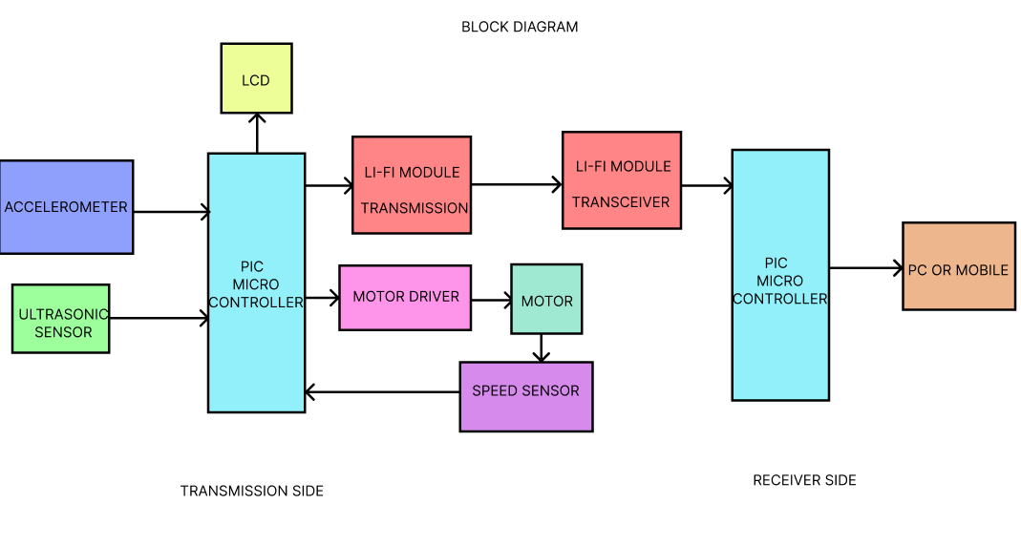

**Working Principle:**

For safe and effective data transfer between cars, the Vehicle-to-Vehicle (V2V) communication system combines sensors, a PIC microcontroller, a motor driver, and Li-Fi modules. Three sensors are used by the system on the transmission side: a speed sensor, an accelerometer, and an ultrasonic sensor. These sensors record crucial vehicle information like speed, acceleration, and distance to other vehicles. The PIC microcontroller receives this data, processes it, and encodes it before sending it.

After that, the Li-Fi transmission module receives the encoded data and transforms it into light signals. LEDs are used to send these modulated light signals to adjacent automobiles. Road safety is enhanced and accidents are avoided thanks to the transmitted data, which includes real-time information on the vehicle's speed, distance, and other crucial factors. The light signals from the transmitting vehicle are picked up by the Li-Fi module transceiver on the receiving end. The light signals are transformed into electrical signals by the receiver, which decodes and displays them on a computer or mobile device. This facilitates better decision-making and enhances traffic flow by enabling the receiving vehicle to view the transmitted data in real-time.

**Existing Systems:**

Network-based communication technologies like Wi-Fi, cellular networks, or Dedicated Short Range Communications (DSRC) are the mainstay of traditional Vehicle-to-Vehicle (V2V) communication systems. By enabling real-time vehicle data transmission, including speed, location, and direction, these systems seek to improve road safety and reduce accidents. Existing systems, however, may have a number of drawbacks. For example, DSRC is costly and difficult to deploy on a broad scale because it requires specialized infrastructure, such as communication towers and roadside units. Furthermore, network-based systems are vulnerable to problems like interference, congestion, and security flaws, especially in congested cities where numerous cars are chatting at once. The dependence on routers and internet connections in Wi-Fi-based V2V systems raises the possibility of network congestion, which can cause delays and the loss of important data. Despite being more accessible, cellular networks frequently have latency and data transmission issues, particularly in remote or sparsely populated locations with patchy network coverage. Additionally, these systems are susceptible to cyberattacks like hacking or data leaks, which could jeopardize the security of vehicle communicationBecause traditional V2V communication methods rely on network infrastructure, which is susceptible to interference, environmental conditions, and bandwidth constraints, they are often less secure and dependable.

**Limitations:**

* Conventional V2V technologies, such as Wi-Fi-based communication and DSRC, rely on expensive infrastructure and are challenging to scale.
* Real-time data transmission is hampered by network-based systems' congestion and security flaws, particularly in heavily populated locations.
* In remote or less connected areas, cellular networks are less effective due to high latency and restricted coverage.

**Proposed System:**

The suggested system offers a major enhancement over conventional network-based systems by introducing a Vehicle-to-Vehicle (V2V) communication solution based on Light Fidelity (Li-Fi) technology. Direct, fast, and secure communication between cars is made possible by Li-Fi, which uses visible light to transport data instead of cellular networks and Wi-Fi, which depend on massive infrastructure. This technology lowers deployment costs and possible points of failure by doing away with the need for intermediary infrastructure like roadside units and communication towers. The technology uses Li-Fi to guarantee real-time data sharing, including vital vehicle metrics like distance, speed, and direction, which can reduce accidents and enhance road safety in general. Li-Fi's direct line-of-sight communication further improves security because the signal is limited to the visible light spectrum, which reduces the possibility of interference or hacking. The system continuously collects real-time data on vehicle movement and surrounds by integrating multiple sensors, including speed, accelerometer, and ultrasonic sensors. Li-Fi is then used to send this data to surrounding cars, enabling prompt notifications of possible dangers or modifications to the road conditions. By addressing the main drawbacks of current systems, the suggested system offers a more secure, effective, and ecologically friendly option for V2V communication.

**Advantages:**

* Li-Fi direct connectivity between cars guarantees dependable data transfer and minimal delay, even in crowded areas.
* Li-Fi's energy-efficient LEDs lower the carbon footprint of the system and promote eco-friendly communication.
* The lack of infrastructure requirements improves the system's scalability and facilitates deployment in a variety of situations.

**Hardware Requirements**

* PIC Microcontroller (e.g., PIC16F877A)
* Li-Fi Module (Transmitter and Receiver)
* Accelerometer
* Ultrasonic Sensors
* LCD Display
* Motor Driver and Motor

**Software Requirements**

* MPLAB IDE
* Embedded C Programming
* UART Communication